**Option # 1: Looping Construct with Floating Point Numbers**

Miriam V. Armendariz

Colorado State University Global

CSC320-1: Programming I

Dr. Vanessa Cooper

May 11, 2025

**Option # 1: Looping Construct with Floating Point Numbers**

**Pseudocode**

**Source Code**

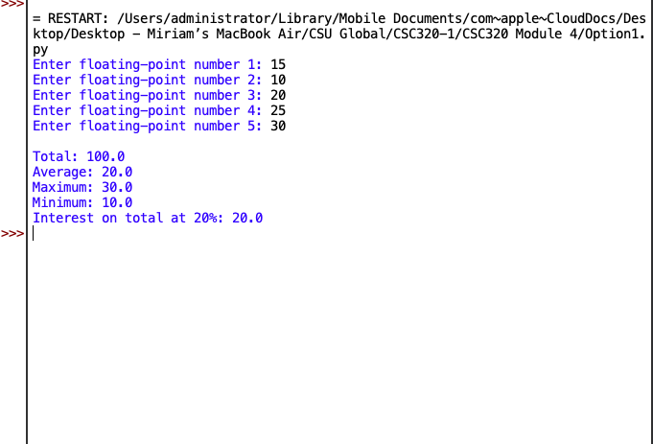

<https://github.com/Miriamva216/floating-point-loop>